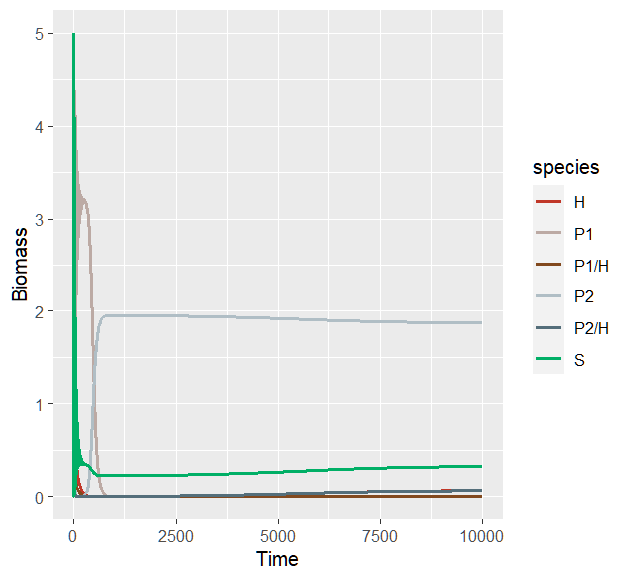
m₂ = 0.055; α₁ = 0.3; β₁ = 0.1 (time 10000, by = 0.01)
P₂ and P_{2/H} will win.

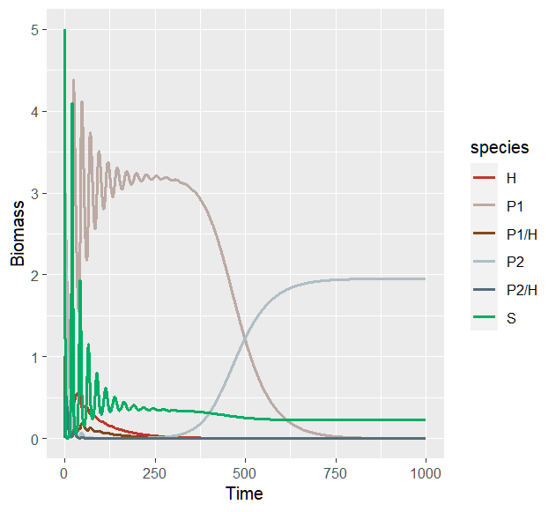
(time 1000, by = 0.01)

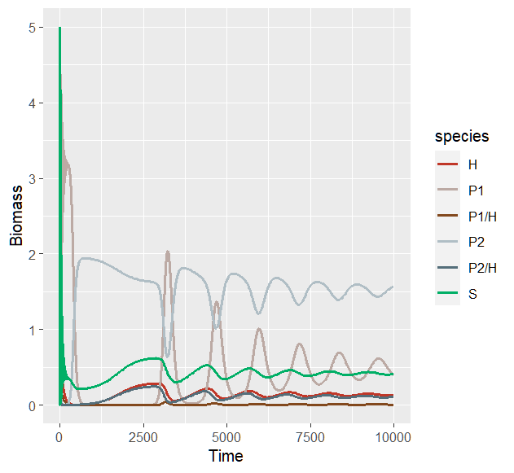
m₂ = 0.05; α₁ = 0.3; β₁ = 0.1 (time 10000, by = 0.01)

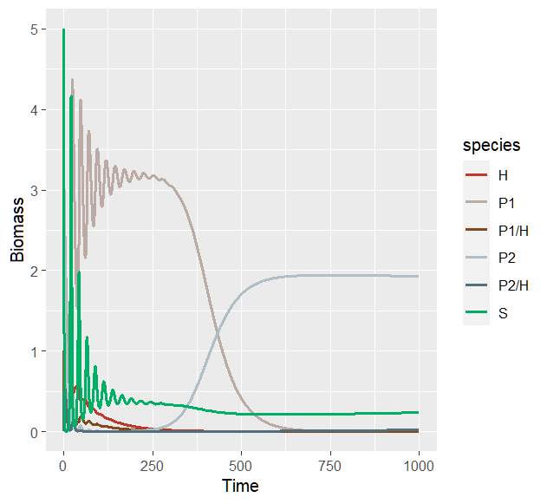
(time 1000, by = 0.01)

